

*Dec 23*

BULLETIN

LIFE WITH GOD FOR THE WORLD

WELCOME TO LAMBRICK PARK CHURCH



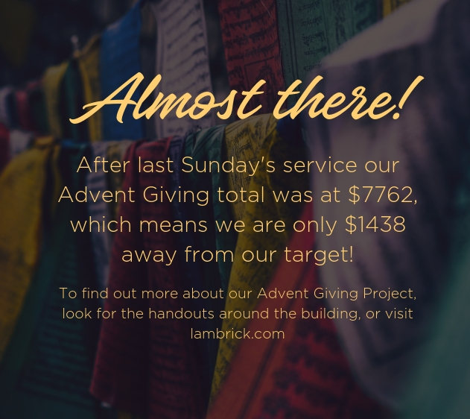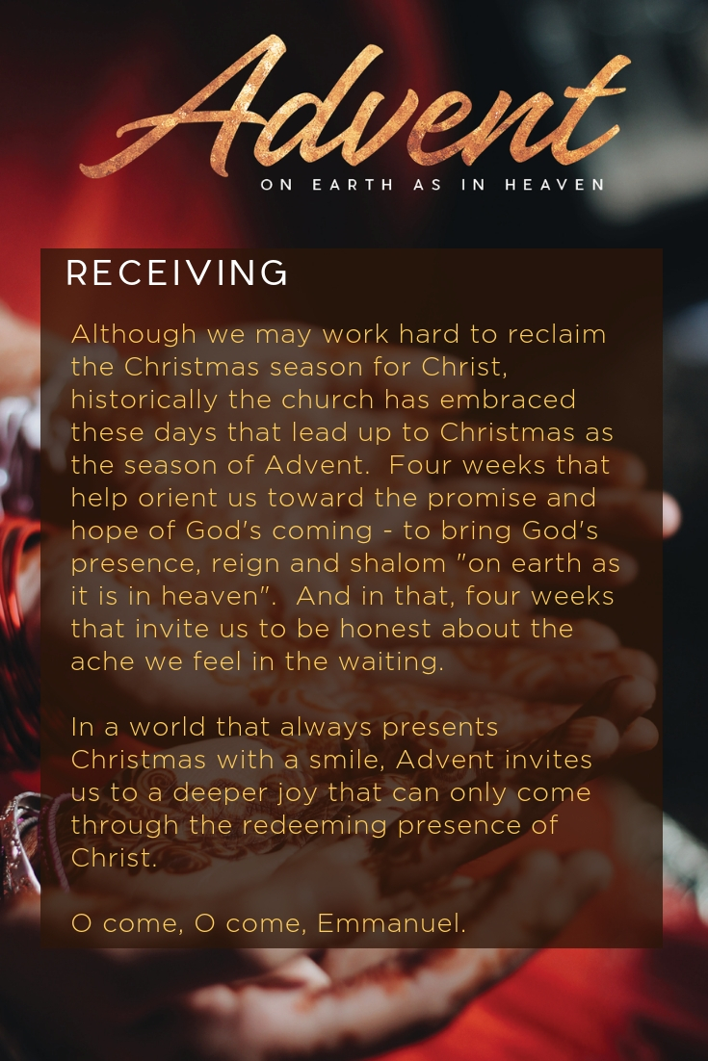

|  |  |
| --- | --- |
| FINANCIAL UPDATE | |
| Budgeted Giving  Sept-Nov | $ 122,558.96 |
| Actual Giving  Sept-Nov | $ 133,999.99 |
| Variance | - $ 11,441.03 |

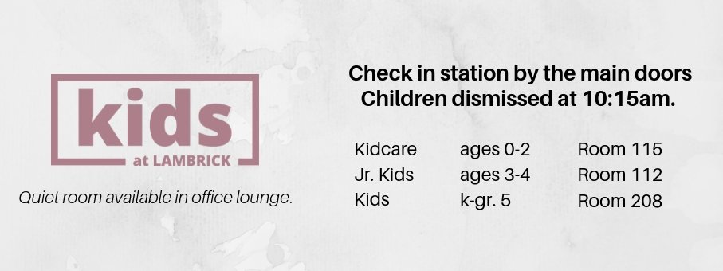 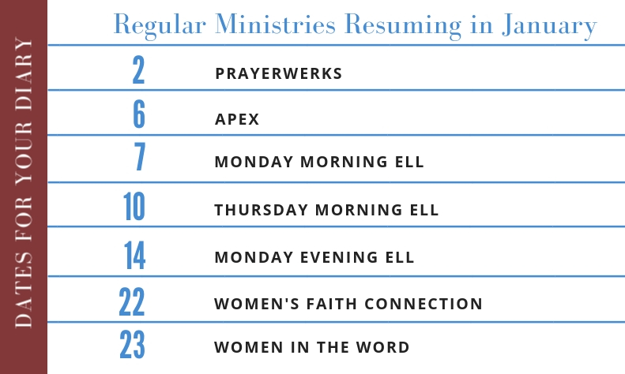

|  |  |  |  |  |  |  |
| --- | --- | --- | --- | --- | --- | --- |
| WAYS TO CONNECT ~ lambrick.com | | | | | | |
| **Sunday** | **Monday** | **Tuesday** | **Wednesday** | **Thursday** | **Friday** | **Saturday** |
| 23  10am Service  Kids@LPC | 24  5pm Family Service  8pm Candlelight Service | 25  Merry Christmas Everyone!  Office Closed | 26  Office Closed | 27  7-8:15am Men’s Bible Study  Office Closed | 28  Office Closed | 29  Office Closed |
| 30  10am Service  Kids@LPC | 31  Office Closed | 1  And a Happy New Year!  Office Closed | 2  7am Prayerwerks | 3  7-8:15am Men’s Bible Study | 4  Office Closed | 5  Agape Meal @ The Mustard Seed  (sign up at the Connect Desk)  Office Closed |
| 6  10am Service  Kids@LPC  & Apex | 7  10:30-12 ELL Beginner | 8 | 9  7am Prayerwerks  7-9pm High School Youth Kick Off | 10  7-8:15am Men’s Bible Study  10:30-12 ELL  6:30-8:30pm Middle School Youth Kick Off | 11  Office Closed | 12  Office Closed |